

**Technical and Business Writing**

**USER MANUAL**

Contents

Group Members: 3

Introduction: 3

Downloading Visual Studio Code: 4

Installing Visual Studio Code: 5

# Group Members:

1. Bilal Ahmed Khan (20K-0183)

# Introduction:

Visual Studio Code, commonly referred to as VSCode, is a free and open-source cross-platform code editor developed by Microsoft. It was first released in 2015 and has since gained immense popularity among developers due to its simplicity, speed, and powerful features. VSCode is built on top of the Electron framework, which makes it highly extensible through a vast array of plugins and extensions that can be installed through the built-in marketplace.

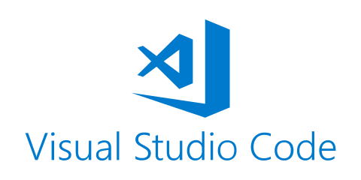One of the key strengths of VSCode is its ability to support a wide range of programming languages and technologies, including popular languages like JavaScript, Python, C++, and Java, among others. It also offers features like syntax highlighting, code completion, debugging, Git integration, and many more, which make it a powerful tool for developers of all skill levels. With its active development community and continuous updates, VSCode is undoubtedly one of the most popular code editors available today, and its versatility and flexibility make it a go-to choice for many developers.

Figure 1 Visual studio code

# Downloading Visual Studio Code:

Here are step-by-step instructions for downloading and installing Visual Studio Code on a Windows computer:

1. Open your web browser and go to the official VSCode website at <https://code.visualstudio.com/>.
2. Click the "Download for Windows" button, and the website will automatically provide you with the appropriate download link.
3. Choose the version of VSCode that matches your Windows operating system. For example, if you're running a 64-bit version of Windows, download the 64-bit version of VSCode.
4. Wait for the installer to finish downloading. This may take a few minutes depending on your internet speed.
5. Once the download is complete, open the installer file. This will be an .exe file.

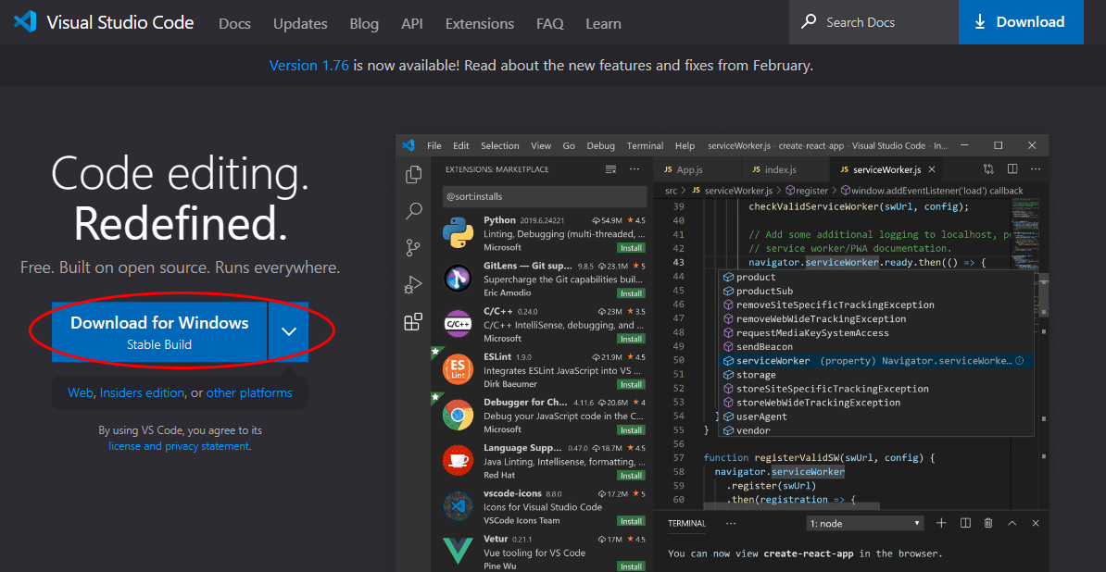By the end of this step, you've successfully downloaded Visual Studio Code on your Windows computer. The steps for the installation of the software will be discussed in later sections.

Figure 2 Visual studio Code download page

# Installing Visual Studio Code:

1. Open the installer file.
2. If you're using a Windows computer, you may see a User Account Control prompt asking for permission to make changes to your computer. Click "Yes" to continue.
3. Accept the agreement and click on next.

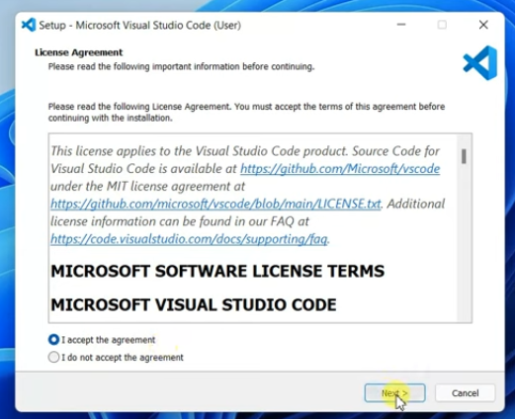

1. 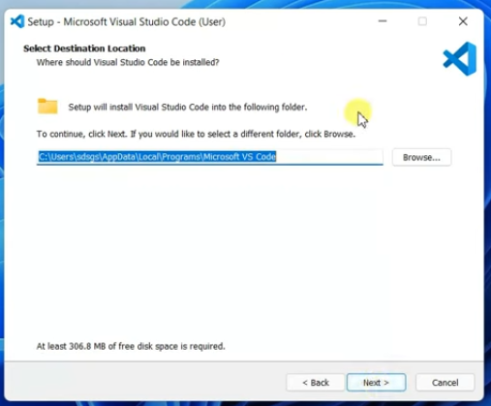Select the location where you want to install VS Code on your PC (It is recommended to install it in the default location) and click next.
2. 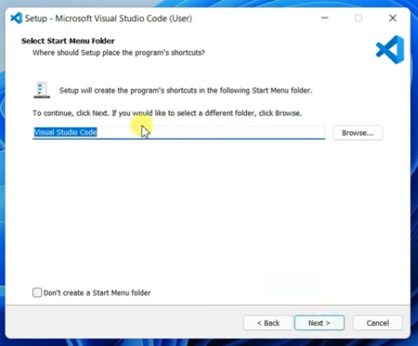Select if you want to create a shortcut for VS Code in Start Menu
3. On the next window check the
   * 1. Create desktop icon checkbox
     2. Add “Open with Code” action to windows explorer file context menu
     3. Add “Open with Code” action to windows explorer directory context menu
     4. Register Code as an editor for supported file types
     5. Add to PATH (requires shell restart) [THIS IS A VERY IMPORTANT STEP]

Once you have checked all the above mentioned options, click on the next button to start VS Code installation.

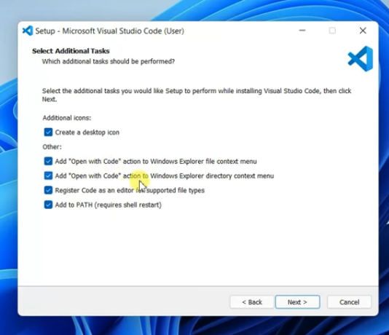

1. After the installation is complete, launch Visual Studio Code by double-clicking the icon on your desktop or by searching for it in your Applications or Start menu.
2. Upon opening Visual Studio Code, you'll be presented with the Welcome page. Here, you can choose to configure your settings, browse and install extensions, or open a folder to start working on your project.

You've successfully installed Visual Studio Code.

**END OF MANUAL**